Parts of a Chef’s Knife
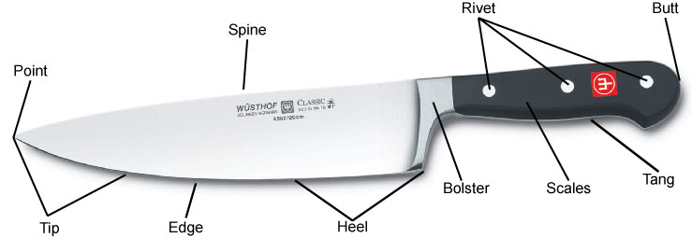

- Edge – The sharpened side of a blade that extends from the point to the heel. The edge may be smooth or serrated. Sharpness is created by grinding each side of the edge to a specific angle (20 degrees for most Western-style knives; 15 degrees for most Asian-style knives)
- Point – The thin, sharp front end of the knife blade useful for piercing
- Tip – The first third of the edge including the point; extremely sharp and thin for precision cutting and carving
- Heel – The rear section of the blade edge; often the widest part of the blade. Used when cutting food that requires more downward force like carrots, hard squash and nuts.
- Spine – The top, blunt edge of the blade opposite the edge; improves blade stability
- Bolster – The transition point between the blade and handle that resembles a thick metal collar or shank. A bolster adds mass in front of the cook’s hand, improving the knife’s balance, stability and strength.
- Tang - The part of the blade that extends into the handle. If it goes all the way to the end of the handle, the knife has a “full tang.” If it runs only part way, the knife has a “half tang” or “partial tang.”
- Scales – The pieces of wood or synthetic material that attach to the tang to form the handle.
- Rivets – The metal pins that join the scales to the tang to form the handle. Cheaper knives may have bonded or glued handles.
- Butt – The end of the handle.

