Food Service Occupations 1 & 2 Name:__________________________
Unit 3: Tools & Equipment

Matching

- Experience B. Training C. Steel/Sharpening Stone D. Sharp
E. Quality AB. Hand AC. Establishment AD. Knives

_____1. Commercial kitchen equipment is usually purchased by the __________________.
_____2. __________using the tools and equipment will make the food preparation process more efficient.
_____3. It is imperative individuals have the proper _________________ before using equipment.
_____4. _________________tools are hand held implements used in preparing foods.
_____5. _________________are the chef’s most important tool in the kitchen.
_____6. Knives should be selected based on ________________ and personal preference.
_____7. __________________ knives are much safer and better to use than dull knives.
_____8. A ____________________should be used to maintain the blade’s sharpness.

Knife Identification

- French knife B. Boning knife C. Utility knife D. Paring knife
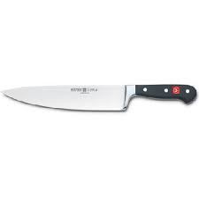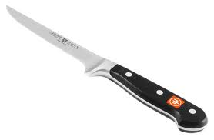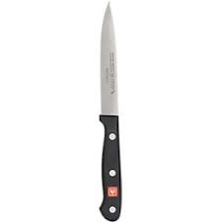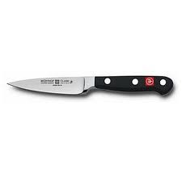

E. Butcher’s steel AB. Slicer AC. Pie/Cake server AD. Oyster knife
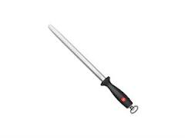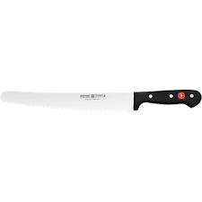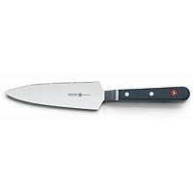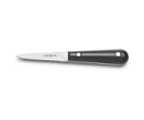

_____9. A wide flat tapered blade to cut dessert wedges.
_____10. A short knife to pare and remove blemishes from fruits and vegetables.
_____11. A short thin pointed blade to remove meat from the bones.
_____12. A narrow blade to slice foods.
_____13. A pointed knife used for a variety of cutting tasks.
_____14. Also known as a chef knife it is used for chopping, dicing, slicing, and mincing.
_____15. A round steel rod to maintain the edge of knives.
_____16. A short thin dull edged tapered blade to open oysters.
Food Handling Tools Identification

- Ladle B. Turner C. Tongs D. Can opener
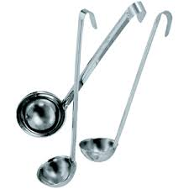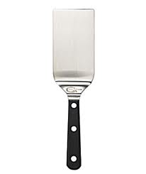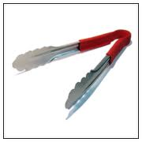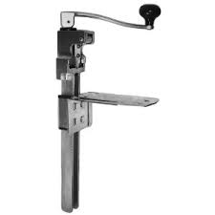

E. Kitchen fork AB. Paddles AC. Skimmer AD. Parisienne Scoop
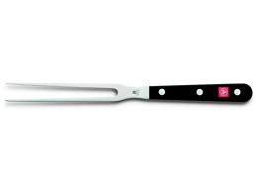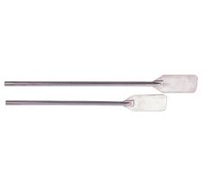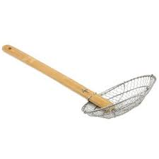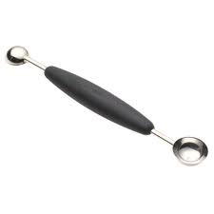
AE. Spatula BA. Scraper BC. Slotted spoon BD. Spoons
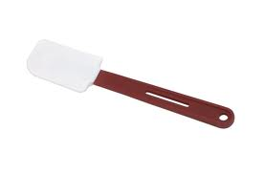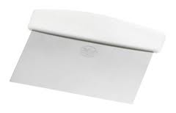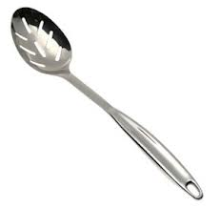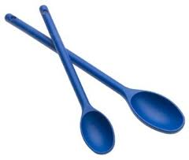

_____17. Long handled paddles to stir food like vegetables in deep pots.
_____18. Stainless steel cups used to stir, mix, and dip foods.
_____19. Flat stainless steel perforated disk to remove grease or food particles from soups/gravies.
_____20. Flexible offset rubber blade used for mixing, stirring, and scraping food.
_____21. Two grippers to pick up and serve foods like lettuce.
_____22. Equipment that is mounted to a table to open large cans.
_____23. Two pronged tool used for holding, slicing, and turning foods like ham.
_____24. Used for stirring, serving, scraping, and spreading foods.
_____25. Wide flat offset blade used to turn foods on the grill like hamburgers.
_____26. A round stainless steel blade used to cut fruits and vegetables like watermelon.
_____27. A spoon with slots to drain foods before serving like fruit cocktail.
_____28. Wide rectangular meat blade for scraping meat blocks and cutting dough.

Ladle Equivalents

- 2 oz. B. 4 oz. C. 6 oz. D. 8 oz.

_____29. A ¾ c. ladle will contain how many ounces?
_____30. A ¼ c. ladle will contain how many ounces?
_____31. A 1 c. ladle will contain how many ounces?
_____32. A ½ c. ladle will contain how many ounces?
Food Preparation Tools Identification

- Strainer B. Wire Whisk C. Box Grater
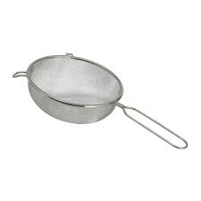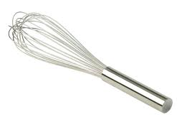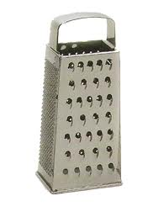
- China Cap E. Colander AB. Hand Meat Tenderizer
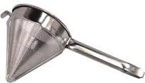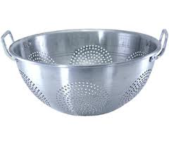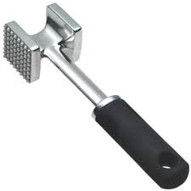
_____33. A bowl shaped strainer used to wash and drain foods like lettuce and pasta.
_____34. Used to whip foods like eggs, cream, gravies, and sauces.
_____35. Perforated metal bowl used to strain and drain foods.
_____36. A metal box with grids to grate foods like cheese, chocolate, and vegetables.
_____37. A pointed strainer used to strain gravies, soups, and sauces.
_____38. A metal hammer to tenderize muscle fibers in tough cuts of meat like rump roast.

Cooking Tools Identification
- Bain Marie B. Bake Pan C. Braiser D. Double Broiler
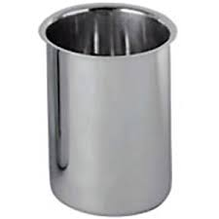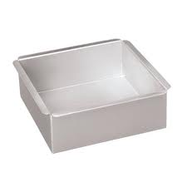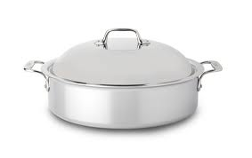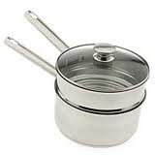

- Iron Skillet AB. Sauté Pan AC. Roasting Pans AD. Saucepan
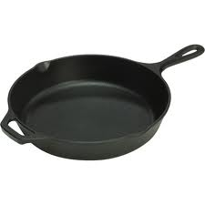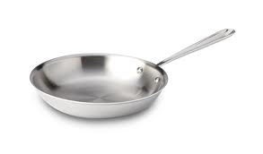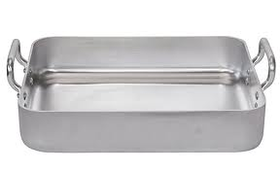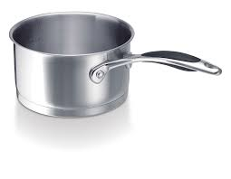

AE. Sauce Pot BA. Sheet Pan BC. Stock Pot BD. Mixing Bowls
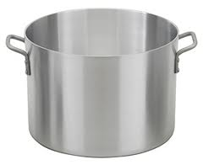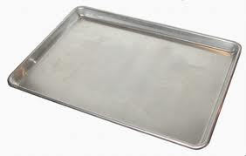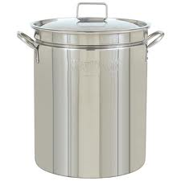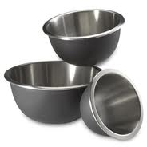

_____39. Large rectangular medium to high walled pan used to bake large cuts of meat like roast.
_____40. Shallow rectangular pan used to bake cookies and sheet cakes.
_____41. Stainless steel storage containers to hold hot water and foods.
_____42. A double pot with hot water in the bottom pan to heat delicate foods like chocolate.
_____43. Large round high walled pot with handles used for boiling and simmering foods.
_____44. A small shallow light pot used for foods like sauces.
_____45. Rectangular aluminum pan used to bake food items like pasta.
_____46. Thick heavy iron to withstand heat and used for broiling and frying foods.

Cooking Tools Identification cont.

_____47. A large round deep pot with handles used for cooking on the top of the range.
_____48. A shallowed wall round pot used for braising, stewing, and searing meats.
_____49. A round sloped shallow pan used to sauté meats and vegetables.
_____50. Used to mix small and large foods together safely and sanitarily.

Baking Tools Identification

- Dough Docker B. Flour Sifter C. Pastry Bag D. Pastry Brush
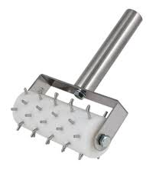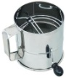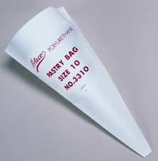

E. Pastry Tips AB. Pie and Cake Marker AC. French Rolling Pin
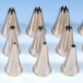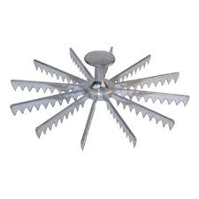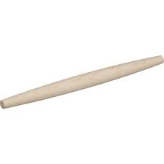

_____51. Solid piece of wood to roll dough to the required thickness.
_____52. Roller with pins used to perforate dough to prevent blistering.
_____53. Cone shaped bag used to decorate cakes or pipe food like duchess potatoes.
_____54. Metal tips with different shapes to decorate cakes and cookies.
_____55. Metal container with a sieve to remove lumps and to add air to a product.
_____56. Guide bar used to mark and cut cakes and pies.
_____57. Brush with bristles used to brush on icing, sauces, or an egg wash.

Measuring Tools Identification

- Measures B. Measuring Cups C. Portion Control Scoops
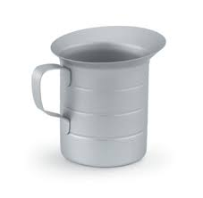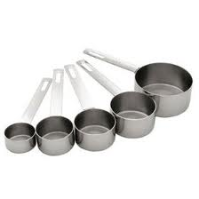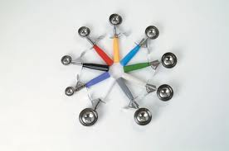
D. Cans
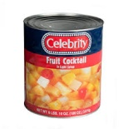

_____58. Used to serve food in accurate amounts and are sized according to number.
_____59. Metal cups that are graduated in quarters like gallons, quarts, and pints.
_____60. Used to measure liquid and dry ingredients in amounts like ¼, ½ , and 1/3.
_____61. Recipes reference to the number of a can.
Measuring Tools/Equivalents Multiple Choice

_____62. A gallon contains ________ quarts.
- 2 B. 4 C. 6 D. 8

_____63. A quart contains ________ pints.
- 2 B. 3 C. 4 D. 5

_____64. Two pounds of “liquid” equals one ________.
- Cup B. Pint C. Quart D. Gallon

_____65. A number 10 can contains approximately ________ quarts.
- 2 B. 3 C. 4 D. 5

_____66. The number that identifies scoops indicates the number of scoopfuls required to make one ___.
- Cup B. Pint C. Quart D. Gallon

_____67. A number 5 can contains approximately ________ quarts.
- 1 B. 2 C. 3 D. 4

_____68. 2 lbs. is the same at which liquid equivalent?
- 8 oz. B. 16 oz. C. 32 oz. D. 40 oz.

Equipment Identification

- Chafing Dish B. Deep Fryer C. Food Processor D. Pressure Steamer
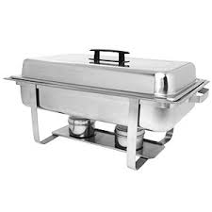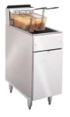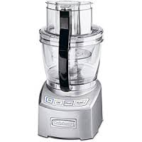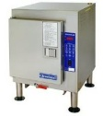
E. Stand Mixer AB. Portion Scale AC. Proofing Cabinet AD. Convection Oven
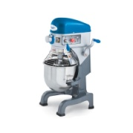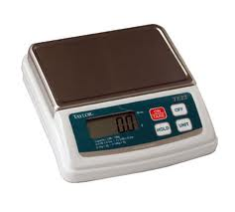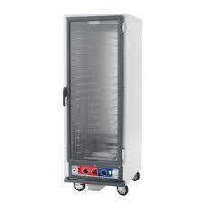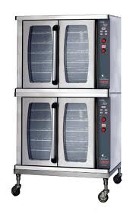

_____69. Used to whip, grind, shred, slice, and chop foods and is placed in a stationary area.
_____70. Cooks food under pressure such as vegetables and meats.
_____71. A warming box used to keep foods hot and for proofing dough without drying out.
_____72. Known as the air flow oven in order to circulate hot air around to avoid uneven baking.
_____73. A pan of water underneath the pan of food keeps it hot on the buffet line.
_____74. Appliance used to puree, chop, grate, slice, and shred foods.
_____75. Used to measure food items for weight accuracy.
_____76. Large kettle used to deep fry foods between 200°-400° degrees.

